Experiment : 6
Date:

STATE CHART DIAGRAM

Aim
To study and represent the workflow of a Library Book Issuing System using a diagrammatic model and to understand how different conditions and validations are performed before a book is issued to a member.

Objective
The objective of this experiment is to analyze the sequence of steps involved in the library book issuing process. It focuses on understanding how the system checks the availability of books, verifies membership details, ensures that borrowing rules are followed, and updates the library records after issuing a book.

Introduction
Libraries maintain a large number of books and handle many users who borrow and return books regularly. Managing these activities manually can be difficult and may lead to mistakes or delays. A Library Management System helps automate these operations and ensures proper control over library resources.
Diagrams such as state or activity diagrams are useful tools in software engineering because they visually describe the sequence of operations in a system. They help developers and users clearly understand how the system behaves under different situations.
In this experiment, a diagram is used to demonstrate the process involved in issuing a book from a library. The diagram illustrates the logical flow followed by the system from the moment a user requests a book until the book is successfully issued and recorded in the system.

System Description
The Library Book Issue System is responsible for managing the process of lending books to registered members. The system ensures that books are issued only when all required conditions are satisfied.
The process begins when a user requests a particular book. The system first checks whether the requested book is available in the library database. If the book is not available, the system informs the user and the process ends.
If the book is available, the system verifies the membership status of the user. Only registered and valid members are allowed to borrow books. If the user is not registered, the system provides a registration process before continuing.
Once the membership is verified, the system checks the number of books that the member has already borrowed. Libraries usually impose a limit on the number of books that can be issued to a member at one time.
If the member has reached this limit, the system will not allow another book to be issued. If the member is eligible, the system proceeds to issue the book and records all necessary information in the database.
Finally, the book status is updated to indicate that it has been issued and is temporarily unavailable for other members.

Diagram Explanation
1. Book Request
The process begins when a member requests a book from the library.
2. Availability Verification
The system checks the library catalog or database to confirm whether the requested book is available.
3. Availability Decision
If the book is not available, the system stops the process and informs the user. If the book is available, the system continues to the next stage.
4. Member Verification
The system verifies whether the person requesting the book is a registered member of the library.
5. Membership Validation
If the membership details are not valid, the system does not allow the user to borrow the book until proper registration is completed.
6. Borrowing Limit Check
The system checks the number of books currently borrowed by the member.
7. Limit Decision
If the member has already reached the maximum borrowing limit, the request to issue another book is rejected.
8. Book Issuing
If the member is eligible, the book is issued to the member.
9. Recording Transaction Details
The system stores important information such as member identification, book identification, issue date, and return deadline.
10. Updating Library Records
The final step involves updating the status of the book in the system to indicate that it has been issued.

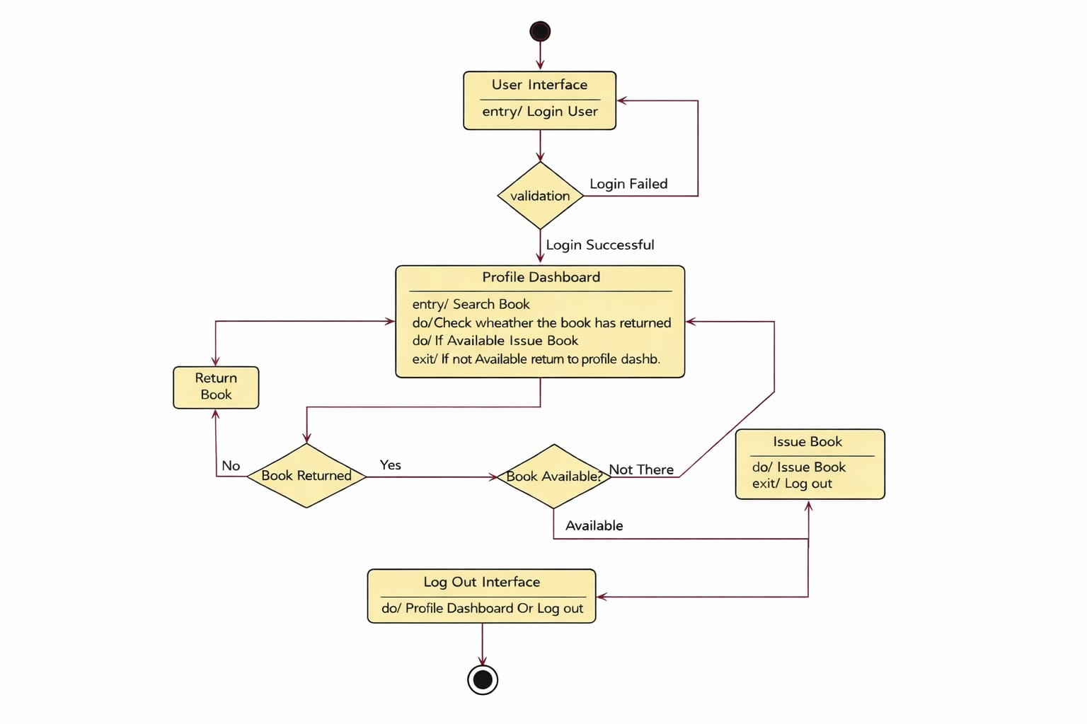

Advantages of Using Flowchart

- Provides a clear representation of the process workflow
- Helps users understand the system operations easily
- Identifies important decision points within the process
- Assists developers during system design and development
- Reduces the chances of logical mistakes in system implementation

Applications
- Library Management Systems
- Academic Record Management Systems
- Inventory and Stock Management Systems
- Banking and Financial Transaction Systems
- Online Reservation and Booking Systems

Limitations
- The system depends on the accuracy of the library database; incorrect data may affect the issuing process.
- If the requested book is not available in the library, the system cannot provide an immediate solution to the user.
- The system allows book issuing only to registered members, so new users must complete the registration process before borrowing books.
- The borrowing limit restricts members from issuing additional books even if they need them urgently.
- The diagram represents only the book issuing process and does not include other library operations such as book return, reservation, or fine calculation.

Result
Thus, the diagram representing the Library Book Issue System was successfully studied and analyzed. The workflow of checking book availability, validating member information, issuing books, and updating system records was clearly understood.

